**Sailing [C]** Rod Stewart **1975** Writers: The Sutherland Bros 1972

**BPM: 64 (128) COUNT: 1 and 2 and 3 and 4 and**

<https://www.youtube.com/watch?v=FOt3oQ_k008> (But in Bm)

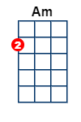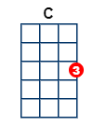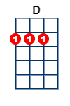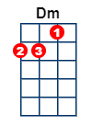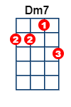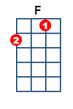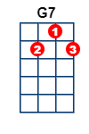

**INTRO: INSTRUMENTAL Count 1 and 2 and 3 and 4**

**[F]** **[F]** **[C]** **[C]** **[F]** **[F]** **[C] [G7 ]**

I am **[C]** sail-ing, **[C]** I am **[Am]** sail-ing

**[Am]** home a**[F]**gain **[F]** 'cross the **[C]** sea ~

**[C]** I am **[D]** sail-ing **[D]** stormy **[Am]** waters,

**[Am]** to be **[Dm]** near you, **[Dm]** to be **[C]** free **[G7]**

I am **[C]** fly-ing, **[C]** I am **[Am]** flying

**[Am]** like a **[F]**bird **[F]** 'cross the **[C]** sky ~

**[C]** I am **[D]** fly-ing, **[D]** passing **[Am]** high clouds,

**[Am]** to be **[Dm]** near you, **[Dm]** to be **[C]** free **[G7]**

Can ya **[C]** hear me, **[C]** can ya **[Am]** hear me,

**[Am]** thru the **[F]** dark night **[F]** far a**[C]**way?

**[C]** I am **[D]** dy-ing, **[D]** forever **[Am]** try-ing

**[Am]** to be **[Dm]** with you; **[Dm]** who can **[C]** say? **[G7]**

**SING LOUDER (Fortissimo)**

Can ya **[C]** hear me, **[C]** can ya **[Am]** hear me,

**[Am]** thru the **[F]** dark night **[F]** far a**[C]**way?

**[C]** I am **[D]** dy-ing, **[D]** forever **[Am]** try-ing

**[Am]** to be **[Dm]** with you; **[Dm]** who can **[C]** say? **[G]**

**INSTRUMENTAL: [F]** **[F]** **[Am]** **[Am]** **[G]** **[G]**  **[Am] [Am]**

**[F]** **[F]**  **[C]** **[C]** **[G] [G]** **[G7] [G7]**

We are **[C]** sail-ing, **[C]** we are **[Am]** sail-ing

**[Am]** home a**[F]**gain **[F]** 'cross the **[C]** sea ~

**[C]** We are **[D]** sail-ing **[D]** stormy **[Am]** waters,

**[Am]** to be **[Dm]** near you, **[Dm]** to be **[C]** free

**[G7]** Oh . . lord to be **[Dm]** near you, **[Dm7]** . to be **[C]** free.

**[G7]** Oh . . lord to be **[Dm]** near you, **[Dm7]**  . to be **[C]** free.

**[G7]** Oh . . lord to be **[Dm]** near you, **[Dm7]** . to be **[C]** free.

**[G7]** Oh . . lord to be **[Dm]** near you, **[Dm7]** . to be **[C\]** f r e e ~